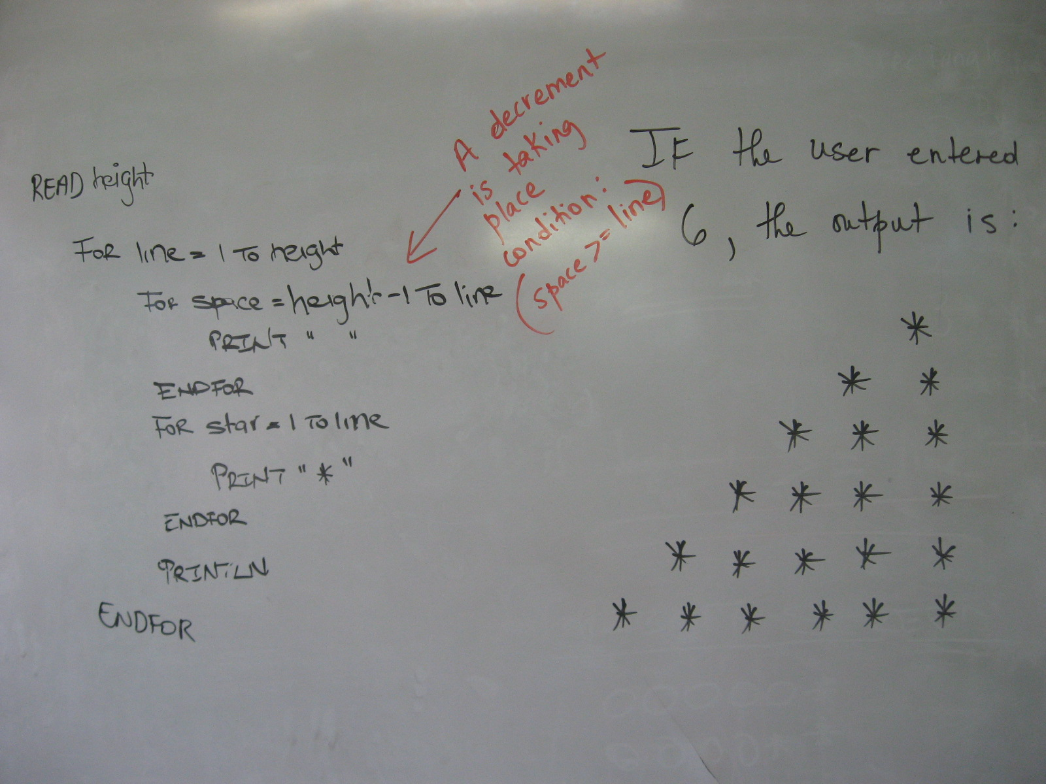
The C Code is:

#include<conio.h>
The executable file is

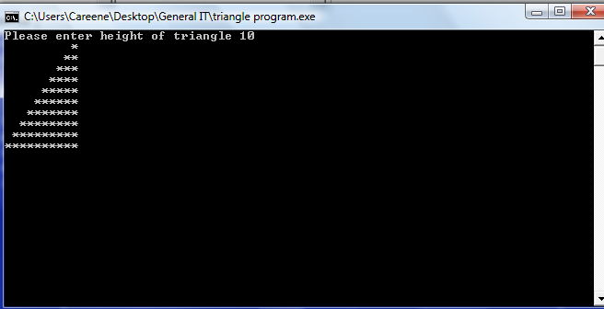
#include<stdio.h>

int main ()
{
int height;
printf("Please enter height of triangle\t");
scanf("%d", &height);
for(int line = 1; line <= height; line++)
{
for(int space = height-1; space >= line; space--)
{
printf(" ");
}
for(int star = 1; star <= line; star++)
{
printf("*");
}
printf("\n");
}
getch();
return 0;
}

